

**Nafferton Parish Council.**

**AGM Chairmans report**

**2024-2025**

**General update of the Parish Council**

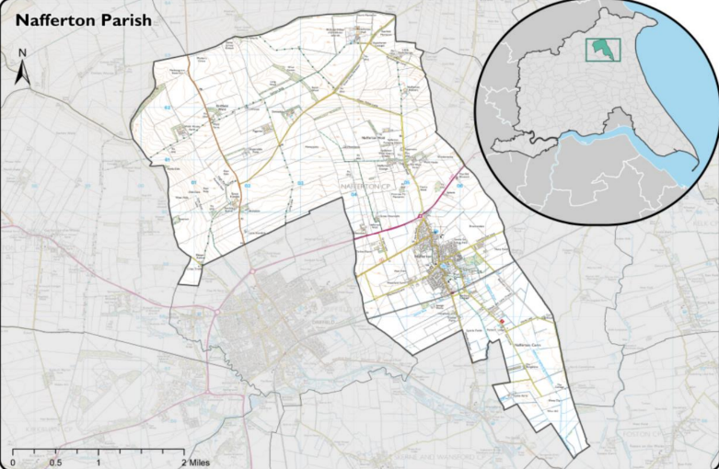**The parish of Nafferton covers an area of circa 32 square miles or 3,074.75 Hectares with a population density of 0.8 persons per Hectare, and serves circa 2600 residents (ONS 2022 survey).**

**Nafferton Parish Council (NPC) comprises of 13 councillors with no current vacant positions.**

**Attendance at monthly meetings, held at Nafferton Recreation Club is generally healthy with no meetings failing to meet quorate requirements.**

**Since the last AGM we have sadly had the resignation of 4 outstanding Councillors, Paul and Cathy Milan and Heidi and Neil Waites. These Councillors contributed an enormous amount, giving up large amounts of spare time, as do all Councillors to benefit the village as a whole. We have however had an influx of four new Councillors, Michael Aston, Peter Ryall, Mike Battams and Chris Melhuish.**

**We also experienced the bitter sweet retirement of our long-standing Clerk Anne Tyler. Bitter as we will all miss her, having been a cornerstone of our community for the last 25 years, Anne has seen many changes to the village over those years I’m sure, but hopefully what makes Nafferton special is still as strong as ever.**

**Sweet because we are sure she will enjoy her very well-earned retirement! She has been succeeded by Suzanne Taylor who has already fitted in well to the job and we all wish her the best and hope she is ready for her 25 years of service!**

**All meetings continue to follow the East Riding of Yorkshire Councils code of conduct and standing orders as set by East Riding Northern Lincolnshire Local Councils Association (ERNLLCA) whom Nafferton PC is a subscribing member.**

**Area updates**

**The Mere**

**No significant changes to the maintenance of the mere are present in the 24-25 report.**

**We have had a conservation report on the mere and are putting the advice given in to action to try to preserve the mere as a community asset in good healthy condition for the village for years to come.**

**Playground**

**Other than ongoing maintenance as it occurs the playground gives little cause for concern, it is a popular and nicely maintained community asset.**

**Bus shelter, Public Access Building and Telephone Boxes**

**The structure of the Bus shelter, while low maintenance, continues to require periodic painting and general cleaning. No major issues have been noted in the last year yet planning should be started for the maintenance of the roof. The public access building remains largely unchanged since the last report. The telephone boxes which are repurposed as community libraries continue to be maintained, with an extensive restoration being completed on the box on Driffield Road by villagers.**

**The Recreation Club and Clubhouse**

**All councillors of Nafferton PC are by default trustees of the Recreation club and Clubhouse by their acceptance of office.**

**The “Clubhouse” continues to be used by various community and sporting clubs complimenting the facilities provided by the Recreation Club and the PC.**

**The Recreation Club continues to provide value for money services for the community with events being regularly held for the benefit of the village and the useful spaces provided by the building being available to hire bringing valuable revenue in.**

**Allotments**

**The allotments continue to be a popular village resource, we have at present got two?? allotments available for rent.**

**General update**

**Over the last year the PC and Recreation Club have faced challenges. There have been efforts made by individuals to hamper the efforts of the PC and Recreation Club for reasons known only to themselves, ranging from complaints to regulators through to constant freedom of information requests. While individually none of these actions are inherently “wrong” together they appear to be an effort to cost the PC and Recreation Club time and money. It is my duty to point out, we on the PC are here to serve the village as a whole. We put aside our individual beliefs, interests or opinions and when making decisions try to serve the best interests of the most people in the village. The Recreation Club is also a village asset, unnecessary costs to village assets, either through vandalism, excessive maintenance through lack of care or even extra administration for the Clerk results in greater costs and therefore costs money on the precept for every villager, as villagers ourselves it is our desire to minimise or even reduce the precept where possible. Sadly this year we had to increase it; a difficult decision we were forced in to.**

**Finally as I have only been chair for three short months, thankyou for tolerating this Chairmans report!**